🎯 Key Business Questions

- Which BMW model generates the highest revenue?

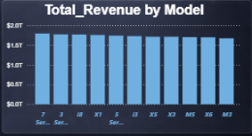

As you see in the chart 7 series models has
Generates Highest revenue in period of 2010-20

- Which region contributes the most sales?
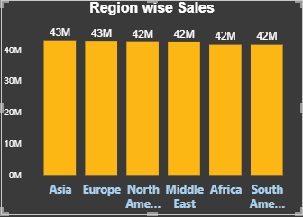

Asia Region Contribute most in sales while 2010-2024

- Petrol vs Diesel vs Electric – which sells more?
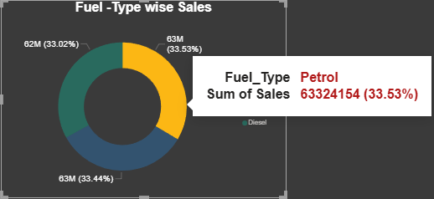

Petrol Fuel Types Cars Model sells more
in 2010-2024 63324154(33.53%)

- Sales trend from 2010–2024?

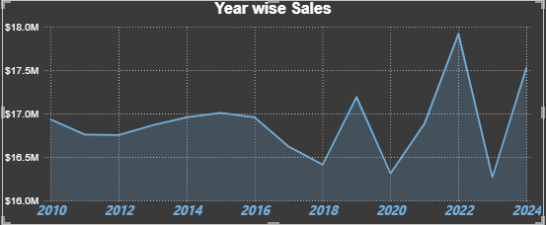
The Year-wise Sales trend shows
relatively stable revenue from 2010–2016
, followed by noticeable fluctuations after
2017. Sales dipped around 2018 and 2020,
likely indicating market slowdowns,
but peaked strongly in 2022, showing
recovery and high demand. Overall, the trend reflects cyclical performance with recent strong growth momentum.

- High vs Low sales classification distribution?

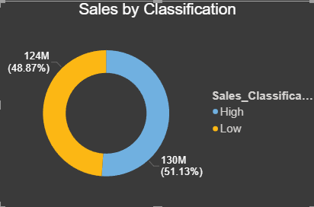
The Sales by Classification chart shows a
nearly balanced distribution between High
and Low sales categories. High classification
contributes slightly more (51.13%) compared to
Low (48.87%), indicating a marginally stronger
performance in high-sales segments.
Overall, the sales distribution is fairly even,
suggesting stable market segmentation.

